Create a US dollar bank account using wise



Document ID | DEV-OB-SOP-002-v1.0
Product | Finance
Environment | ---
Confidentiality Level | Internal / Restricted

CONTENTS
1 DOCUMENT INFORMATION 3
1.1 Validation 3
1.2 Document Distribution 3
1.3 Version Control 3
2 PURPOSE & CONTEXT 4
2.1 About this document 4
2.2 Scope 4
2.3 Roles & Responsibilities 4
2.4 Terminology 4
2.5 Conventions Used 5
3 CREATE A WISE ACCOUNT 6
4 GET YOUR US ACCOUNT DETAILS 12
5 ADDING YOUR LOCAL BANK INFO TO GET PAID 16
6 SEND MONEY FROM WISE 20

DOCUMENT INFORMATION

Validation
Name |  | Role | Date (dd/mm/aa)
Issued by | Oscar Rondon | Technical Writer | 09/01/2026
Verified by | Vishal Bavadiya | Developer
Approved by

Document Distribution
Normal | Role
Oscar Rondon | Technical Writer
Anthony Bures | Digital Development Manager
Vishal Bavadiya | Developer

Version Control
Version | Date | Author | Description of changes
1.0 | 09/01/2026 | Oscar Rondon | First version of the Wise Account Setup onboarding document

PURPOSE & CONTEXT

About this document
This Standard Operating Procedure (SOP) describes the steps required to create a Wise account, obtain U.S. dollar account details, add local bank information, and send money from Wise. The document provides guidance to ensure payments can be received and transferred correctly using the Wise platform.

Scope
This SOP applies to contractors and personnel who are required to set up and use Wise to receive payments in U.S. dollars from ZTERS and transfer those funds to a local bank account.
In scope:
- Wise account creation
- Account verification process
- Retrieval of U.S. banking details
- Sending money from Wise
Out of scope:
- Contract negotiation
- Payment approval processes
- Wise account troubleshooting & local bank policies

Roles & Responsibilities
Role | Responsibilities
Contractor | - Creating and maintaining a wise account  - Sharing U.S. account details with ZTERS  - Managing transfers to their local bank
ZTERS Accounting Representatives | Receive the Wise U.S. account details provided by the contractor and use them for payment processing.

Terminology
Term Used | Description
Wise | A financial platform used to receive, hold, convert, and send money internationally.
USD Account Details | Banking information provided by Wise, including account number, routing number, and related details, used to receive payments in U.S. dollars.
Local Bank Account | A personal bank account added in Wise to receive transferred funds in the contractor’s local currency.
Verification | The process of confirming identity and addressing information within Wise using official documents.

Conventions Used
The following structures are used as recommendations.
Tip: A recommendation or useful advice

Warning: A warning or important notice

Note: A notice.

CREATE A WISE ACCOUNT
Creating a Wise account allows ZTERS team members to receive payments in US dollars easily and legally. Wise provides a USD account with local banking details, enabling fast, low-fee international transfers and simple conversion to your local currency when needed.
- Go to https://wise.com/
- Select Sign Up in the upper-right corner of the page.
- Enter your email address and click Next. You could also sign up using your Google, Facebook, or Apple account.
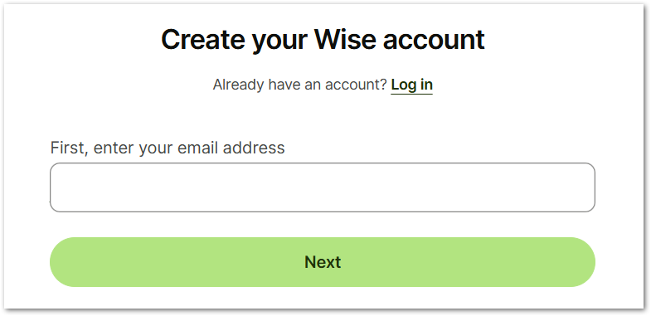
- Check your email and confirm the email address. Once it’s confirmed, you will be redirected to continue setting up your Wise account.
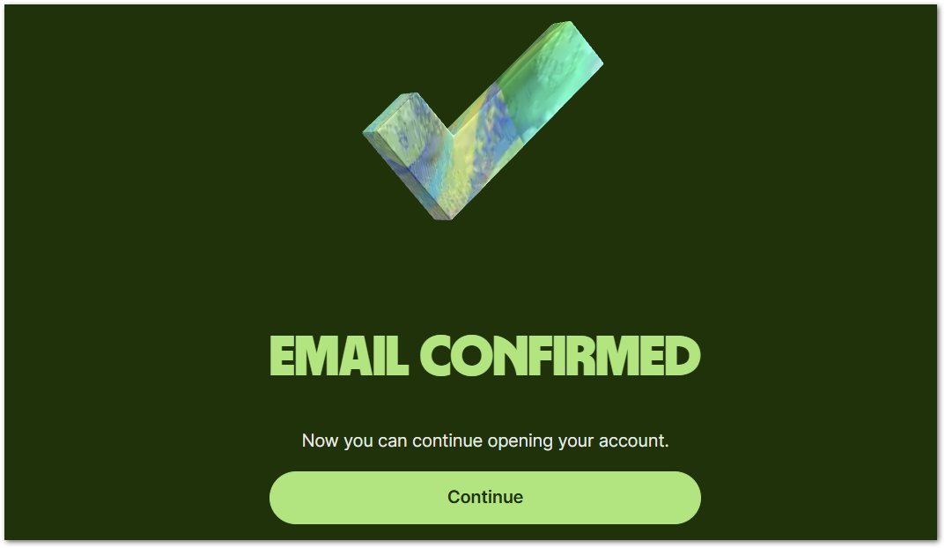
- When prompted for the account type, select Personal Account, which is the option used to receive USD payments from ZTERS.
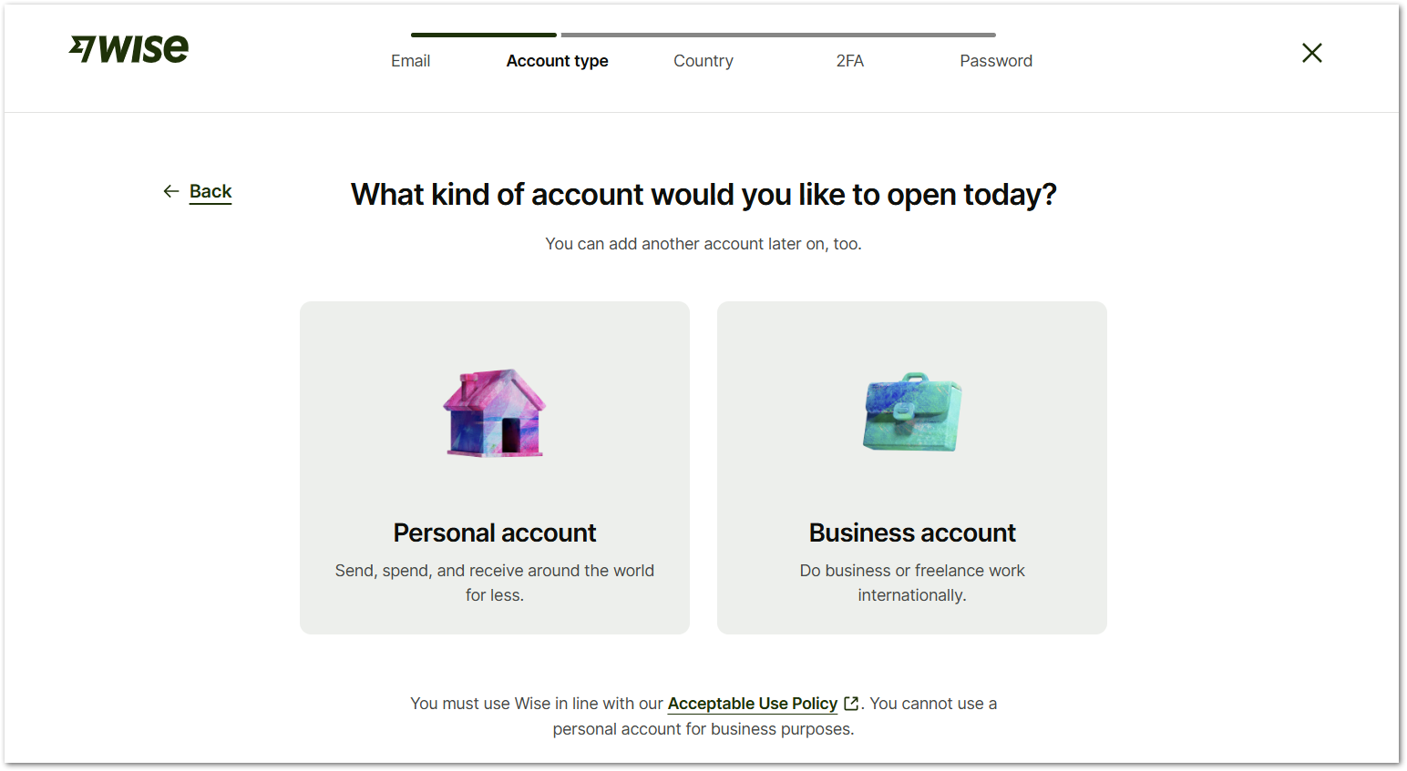
- Select your country of residence from the country dropdown menu and click Continue. Depending on your country, Wise may allow you to:
- Send money abroad.
- Receive money.
- Hold and convert money.
- Spend abroad with a card (optional for some countries).
- Earn and return (optional for some countries).
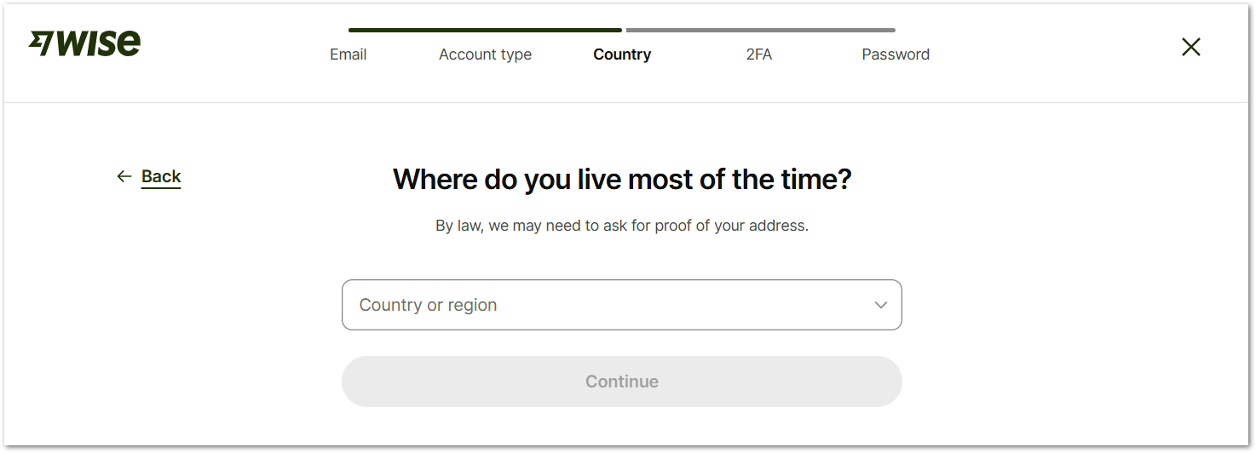
- Enter your phone number and click Send verification code, to verify it. The prefix number depends on the country you selected in the previous step.
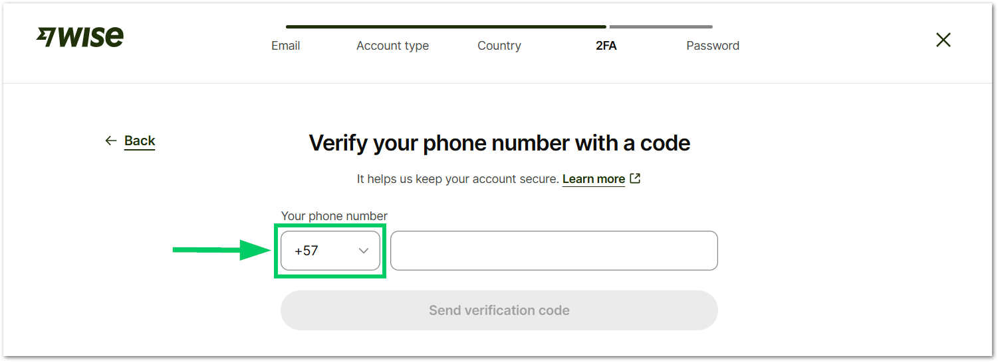
- After receiving a text message, enter the 6-digit WISE code and select Done.
Tip: You can change your phone number to get a new code.

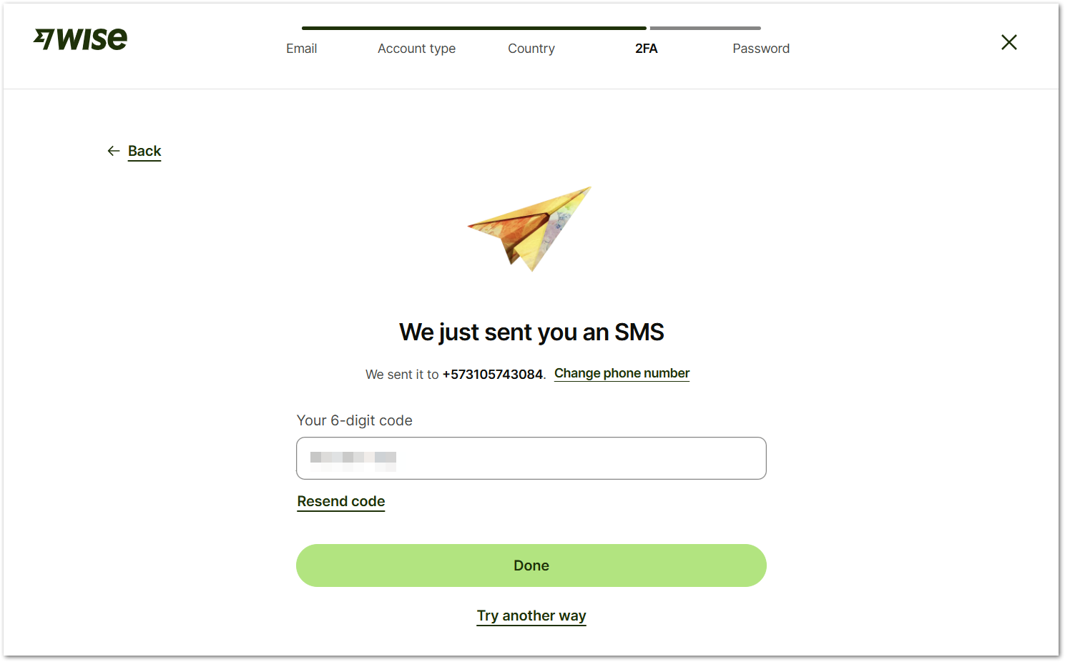
- Create a password for your account and select Continue. Make sure your password:
- Contains a letter
- Contains a number
- Has 9 or more characters
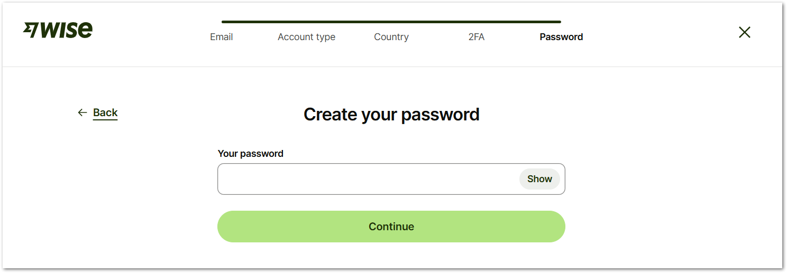
- In the next screen, enter more personal details for your account and select Save and continue.
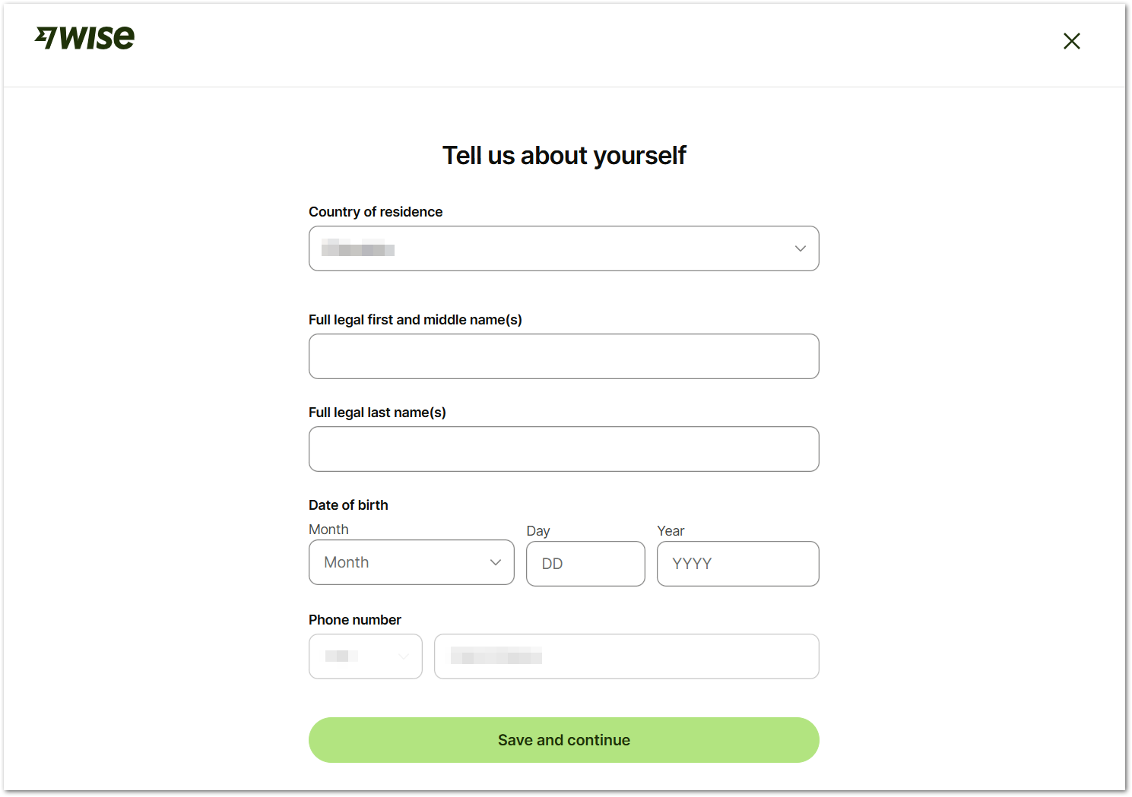
- Enter your address or post code to finish setting up your account.
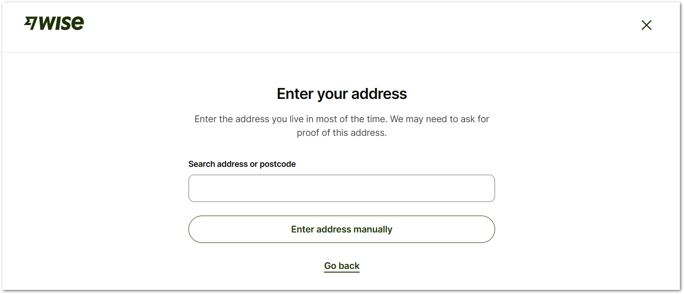
You will be prompted to select an address and confirm the information about it. Select Confirm and continue when you complete the information.
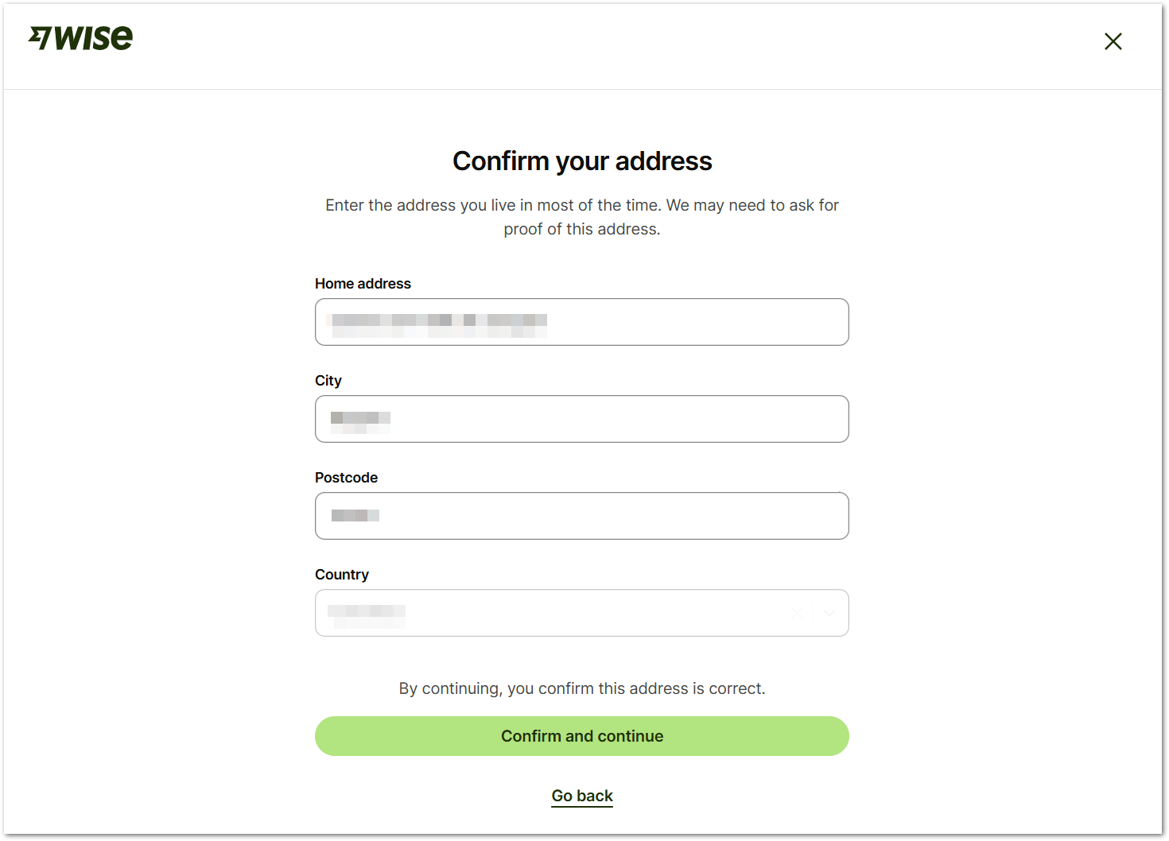
- You have finished setting up your Wise account. You can now explore the dashboard before continuing.
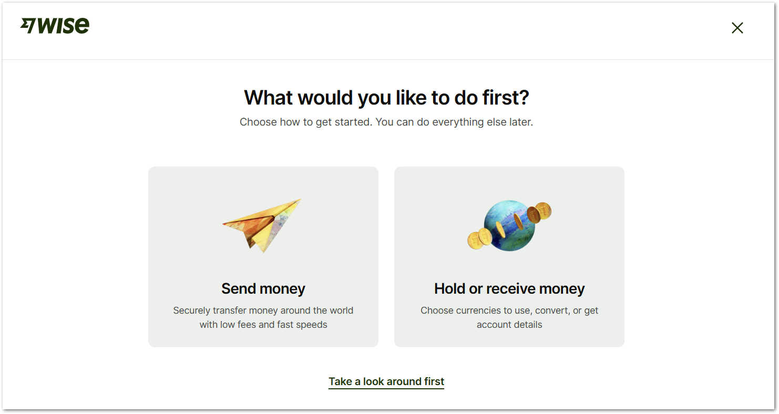
- To start receiving money in USD, select the button Add a currency to your account.
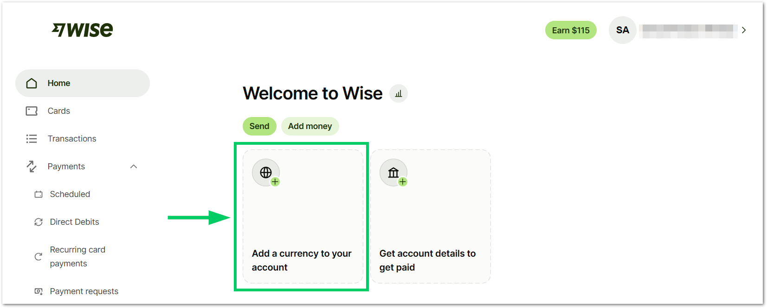
By adding a USD balance, you will be able to:
- Hold and convert 40+ currencies.
- Receive money from abroad

- Select US dollar from the dropdown menu and click Confirm. By selecting this option, ZTERS will be able to pay you in USD.
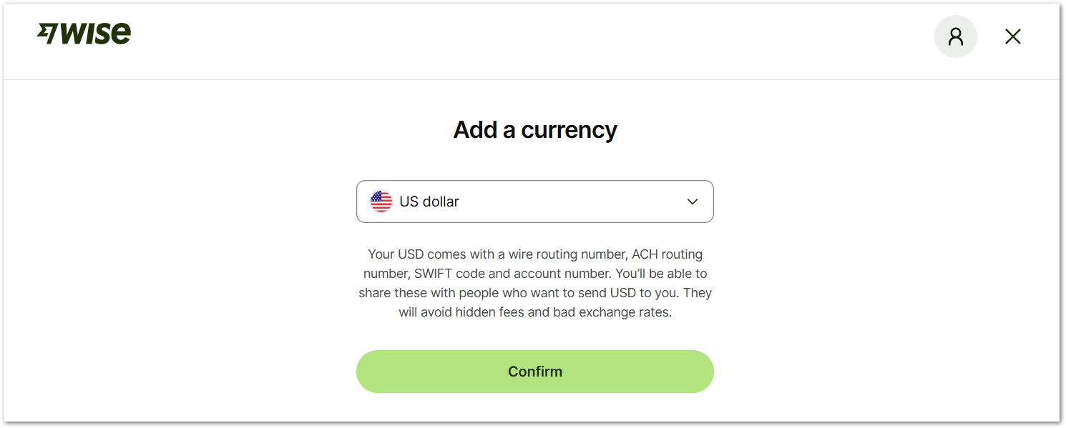
- Confirm the currency. After this, you will see the balance in your account.
Tip: You can always update your personal information in Security & Private settings.

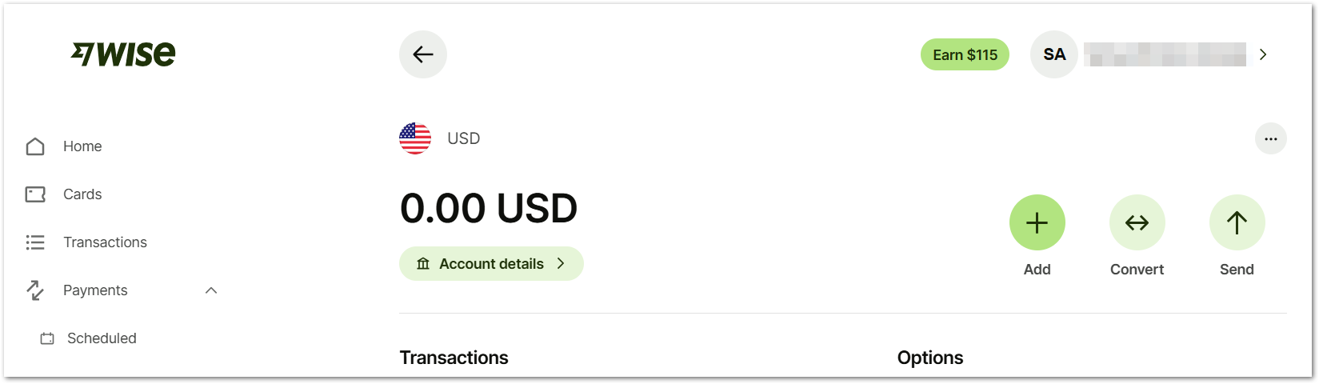

GET YOUR US ACCOUNT DETAILS
Once your Wise account is set up, you can generate your USD account details directly from the platform. These details (bank name, routing number, and account number) must be shared with ZTERS to receive payments as if you had a local US bank account, with full transparency and low fees.
- In your WISE home page, select Account details.
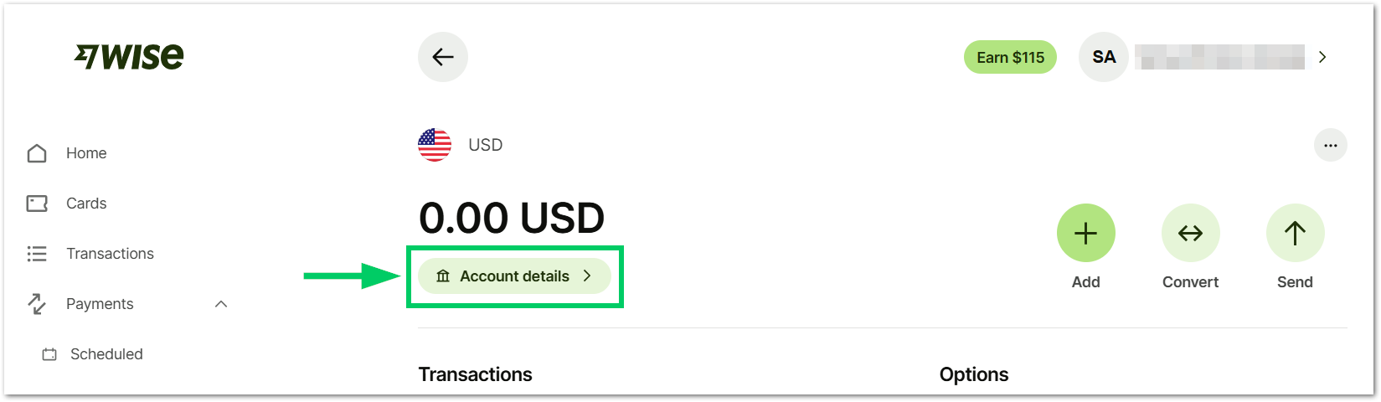
- To get your account details, you will need to add 20 USD to your WISE account. This amount is refundable and required only for verification purposes. Select Continue.
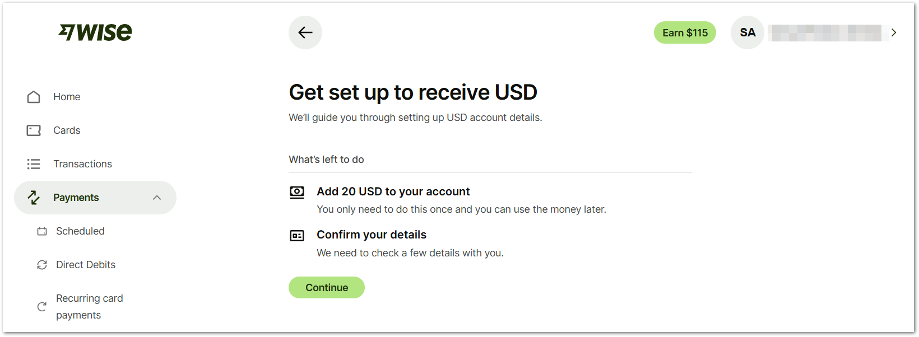
- You can select the way to add 20 dollars into your account. The following fees and processing times may vary depending on your country and payment provider:
Method | Fee | Transaction Time
Debit card | 0.25 USD | Seconds
Credit card | 1.31 USD | Seconds
Connected bank account (ACH) | 0.03 USD | Depending on the bank
Wire transfer | 6.11 USD | 1 day
International wire | 6.11 USD | 7 days

Tip: Both the Debit card and Credit card methods are recommended if you’re outside of the USA.

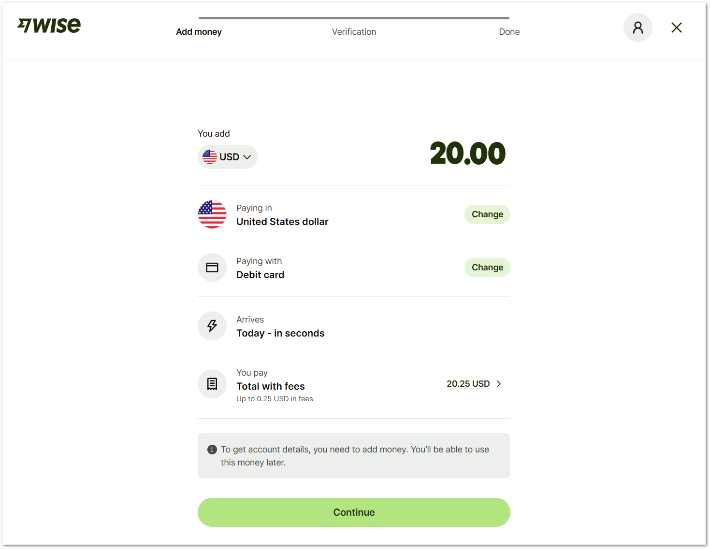
- Select your payment method and click Continue.
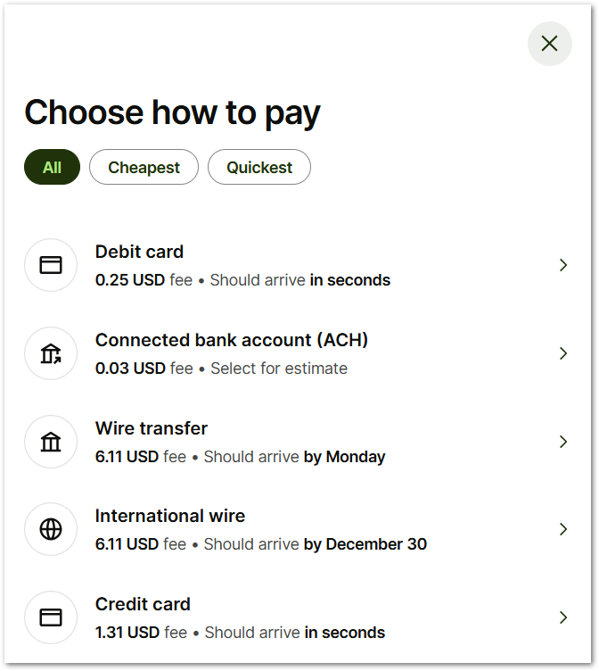
- Add your payment method details and select Pay.
- If you are a US citizen, confirm your SSN. Otherwise, select the option to verify as a non-US citizen. In the next window, select Continue to confirm that you’re not a US citizen.
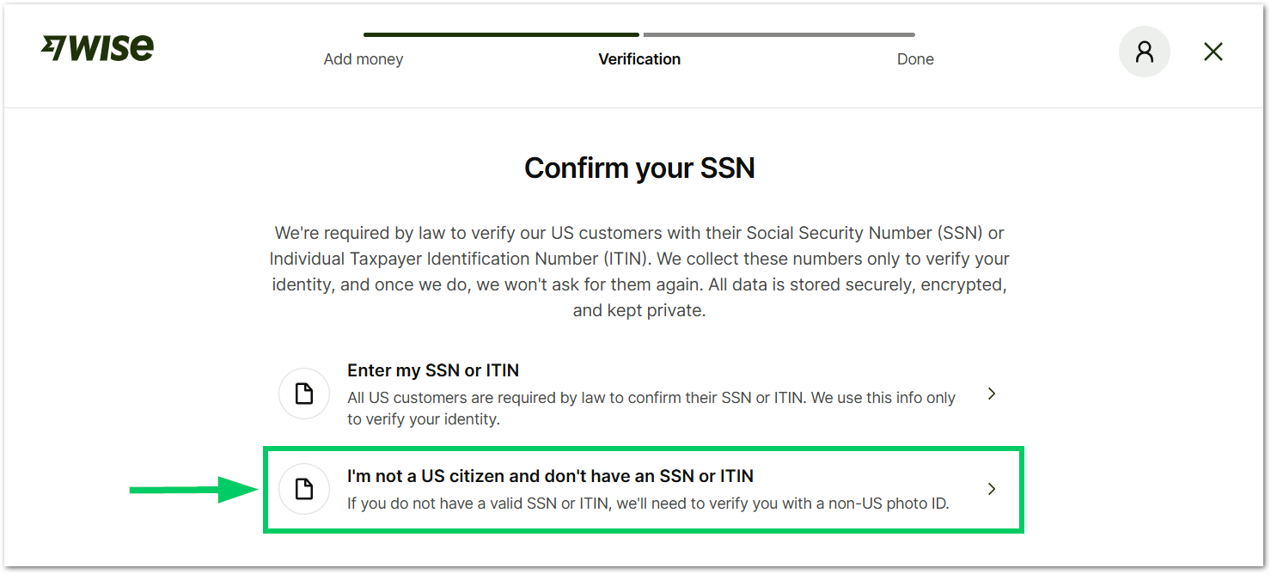
- Now, the system will ask you to switch to your phone by scanning a QR code to take a picture of your ID document and your face. This step appears only if you are completing the form from a computer.
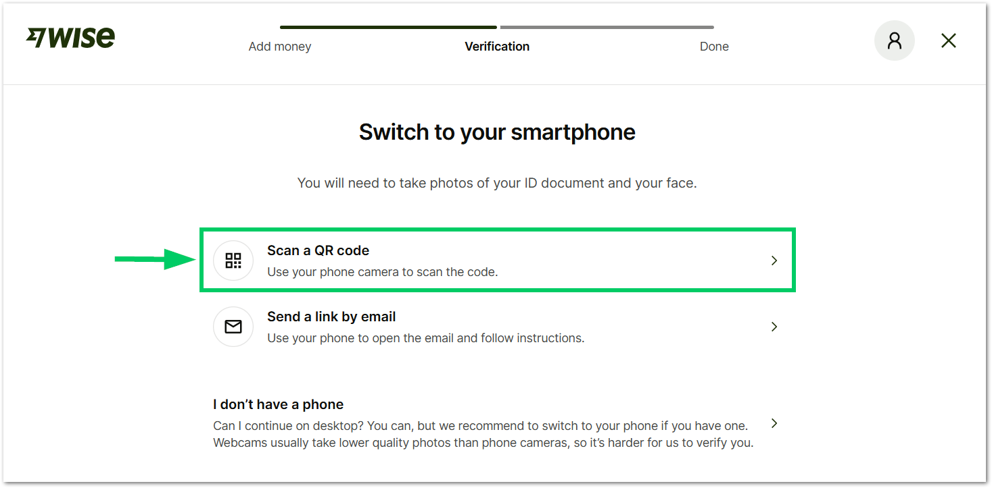
- From your phone, follow the instructions to take a picture of your ID document. The system will ask about the issuing country and document type; the following are allowed:
- Passport
- Driver’s license
- National ID
- Refugee identity document

- Agree to the WISE biometric data processing notice for your account setup and start capturing photos of your document and face.
- The system will ask you to upload a document to verify your address. The following documents are accepted for address verification:
- A utility bill (gas, electric, or landline phone).
- A bank or credit card statement.
- A council tax bill.
- A vehicle registration or tax document.
- A photo driving license with your address and expiry date.
- A rental agreement — it must display the address, along with your name and your landlord's name, and include both signatures, as well as the start and end dates of the tenancy.
- Other documents issued by a government or financial institution (N26, Monzo, Bunq, Monese).
Tip: Make sure you have the address verification document already uploaded to your phone, so the process can be completed faster.

- After you upload the address verification documents, WISE will send you a notification for your account verification process. Verification may take only a few minutes if your documents are clear and readable. Otherwise, it can take up to 5 business days.
- Once your account is verified, check your account detail information here:
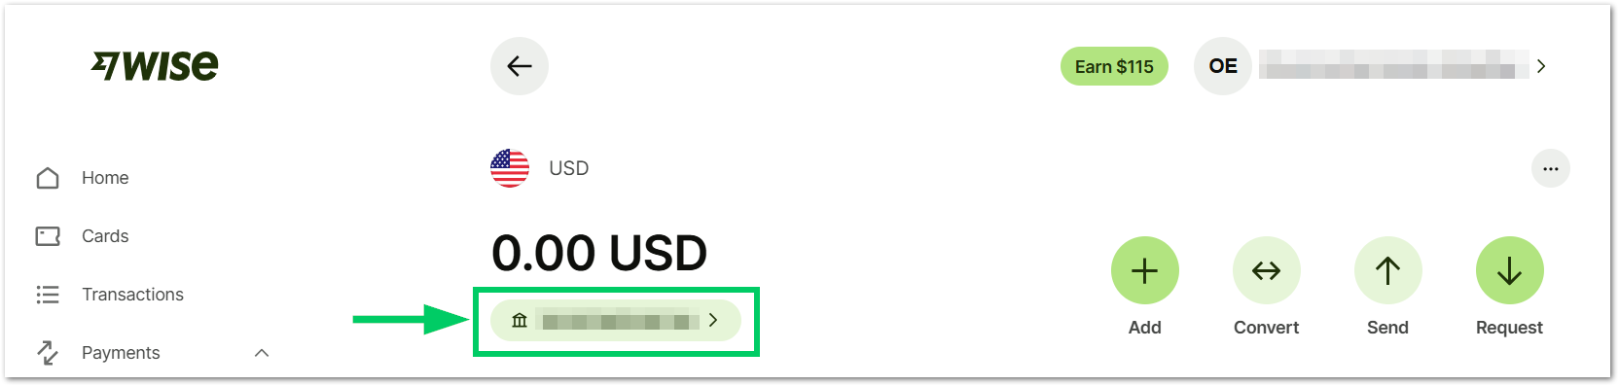
Your Wise US Inc account details include:
- Name
- Account number
- Account type
- Routing number (for wire and ACH)
- Swift/BIC
- Address
Feel free to share this information with the appropriate people at ZTERS to get paid in US dollars. Afterwards, you can send the money to your local bank.

ADDING YOUR LOCAL BANK INFO TO GET PAID
To send money from Wise to your local bank, you first need to add your bank account details in the Wise platform. Once saved, you can securely transfer funds, choose the amount and currency, and track the transfer until it reaches your bank account.
- In the WISE home page, select the Send button.
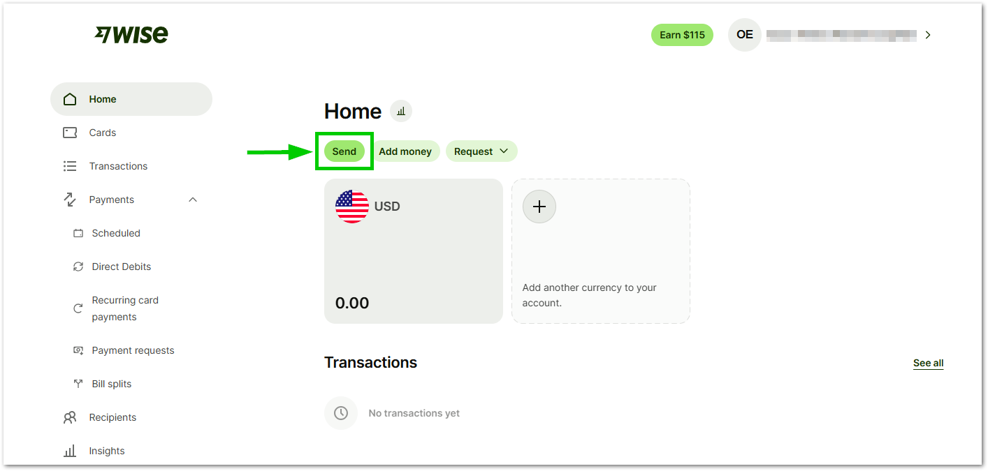
- Select the country where you want to send money.
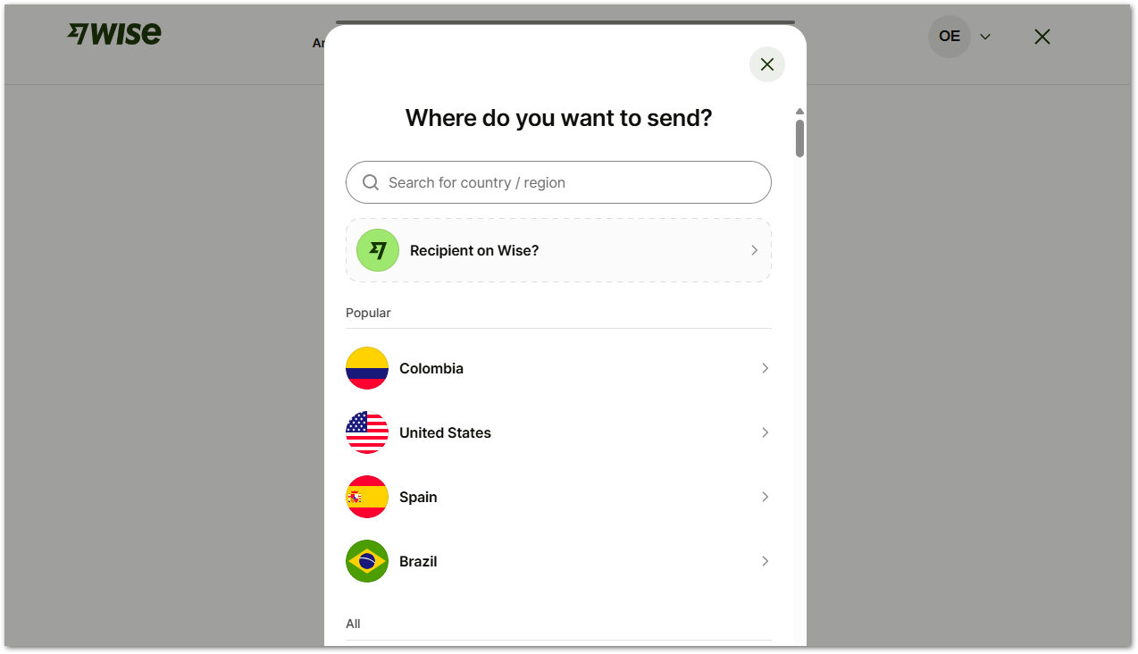
- Wise will show you exactly how much money you will get, based on the money you send through the system.
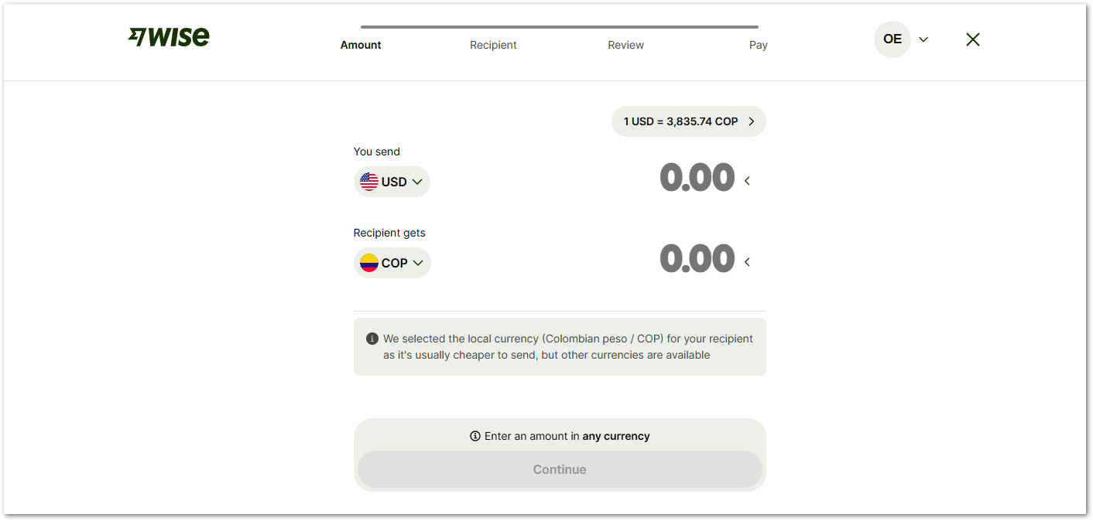
Each country will have their own policies and fees when it comes to sending money to a specific currency. As an example, if you want to send 1.000 USD to India, you will receive 90.252,56 Indian Rupee (Dic 2025). The total fees go up to 7.33 USD per transfer. Other Fees may apply depending on your bank.
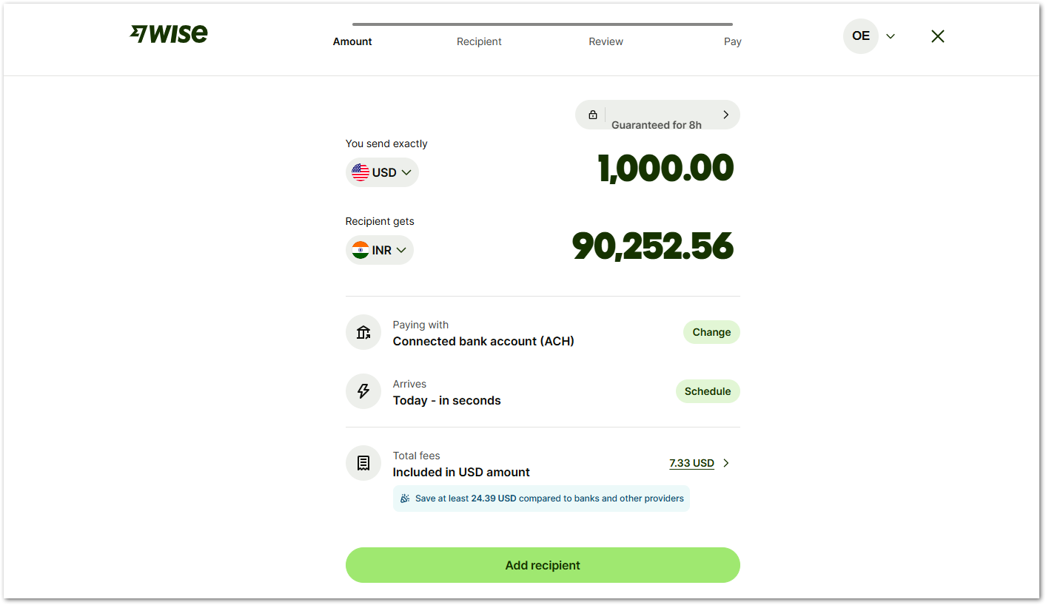
- For Mexico, if you send 1.000 USD, you will receive 17.810,52 Mexican Pesos (Dic 2025). The total fees go up to 8.29 USD per transfer.
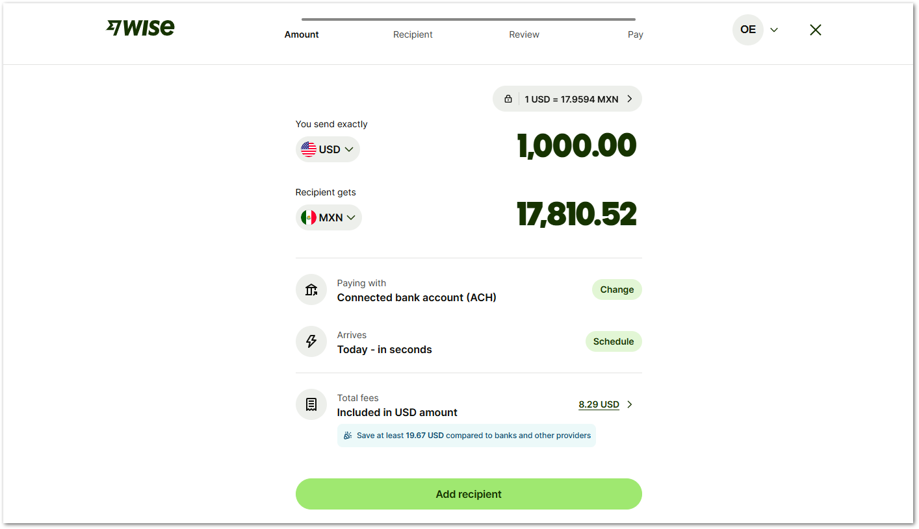
- Select Add recipient to complete the account’s information where the money will go.
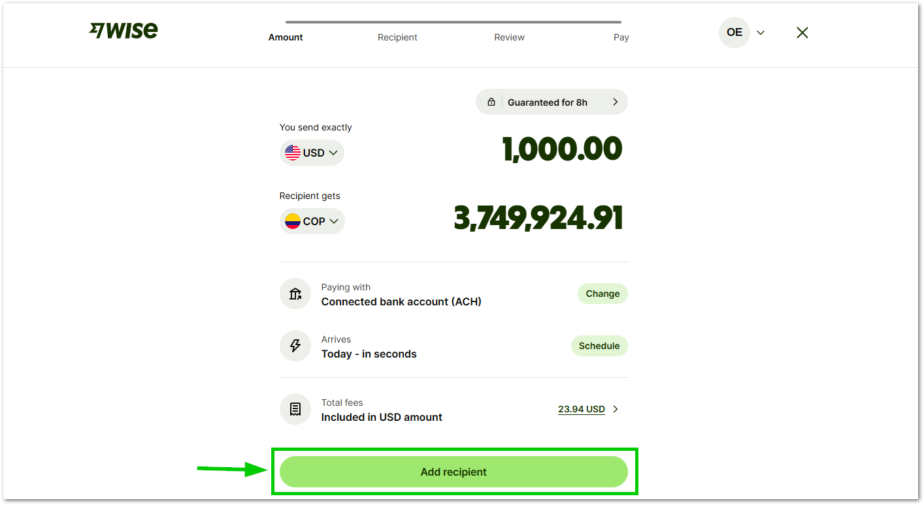
- Select Bank Details to add the bank account details.
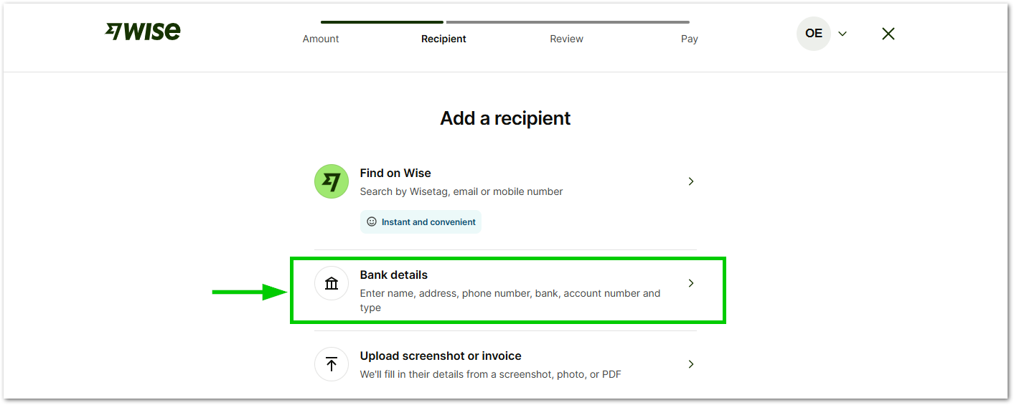
- Select Myself if you’re the person receiving the money.
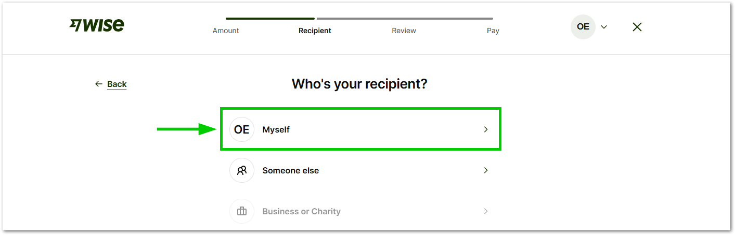
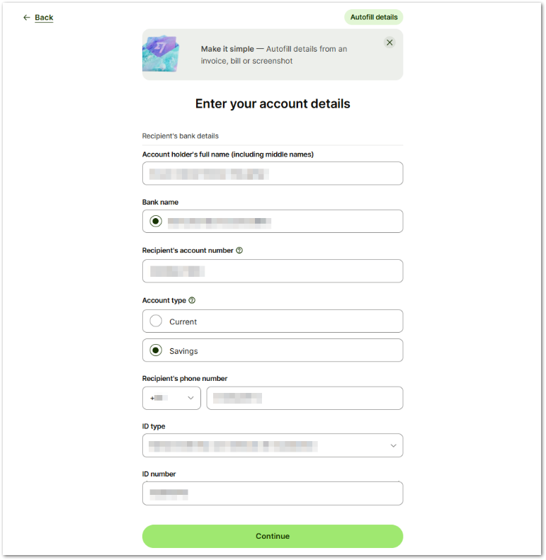
- Enter your account details:
- Account holder’s full name.
- Bank name.
- Recipient’s account number.
- Account type.
- Recipient's phone number.
- ID type.
- ID number.

- Select the reason for using Wise, you can check Receiving salary or pension.
- Select how much money you expect to move using Wise in a year.
- Validate your information in the summary screen, select Continue to Payment.
Tip: The account added can be used later for future payments. However, this connection can also be removed in Wise account settings.

SEND MONEY FROM WISE
After receiving funds in your Wise account, you can easily send money to your local bank in your home country. Wise handles the currency conversion at real exchange rates and transfers the money quickly, with clear fees and no hidden charges.
- In your WISE home page, you should have a payment from your company.
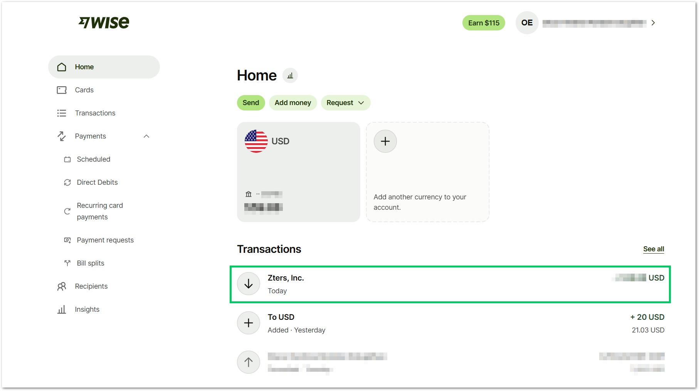
- Select your USD account > select Send.
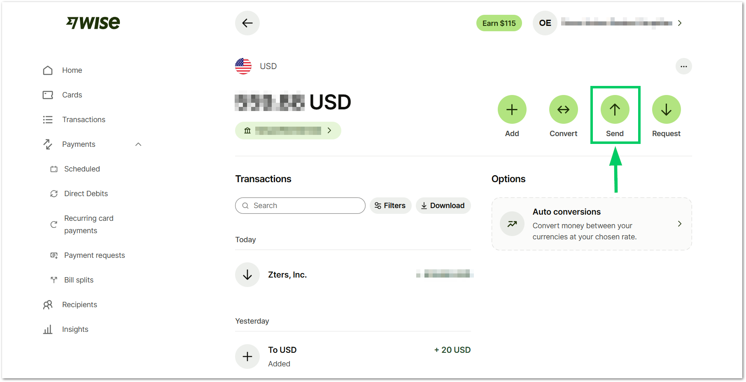
- Select the country where you will send or use the search bar to find it.
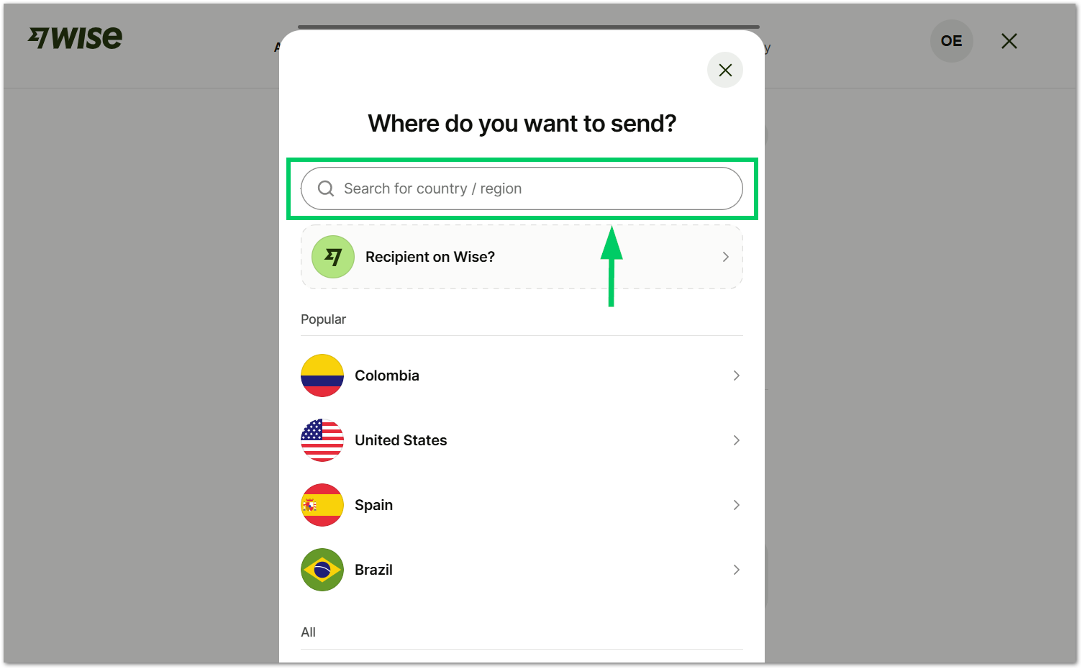
- You will see the exchange rate for the country that you selected. Select the Amount available option to send all your money.
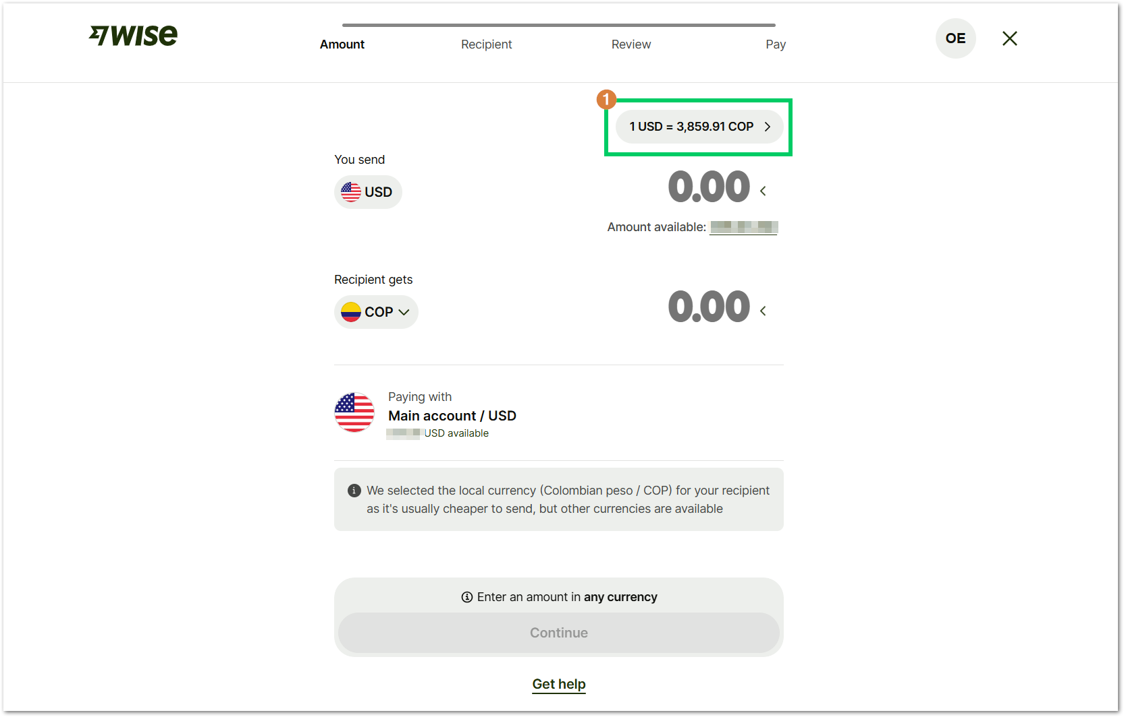
- Below, you will see the fees applicable to the country where you send the money. Under Rate guaranteed, you can review the exchange rate locked for your transaction.
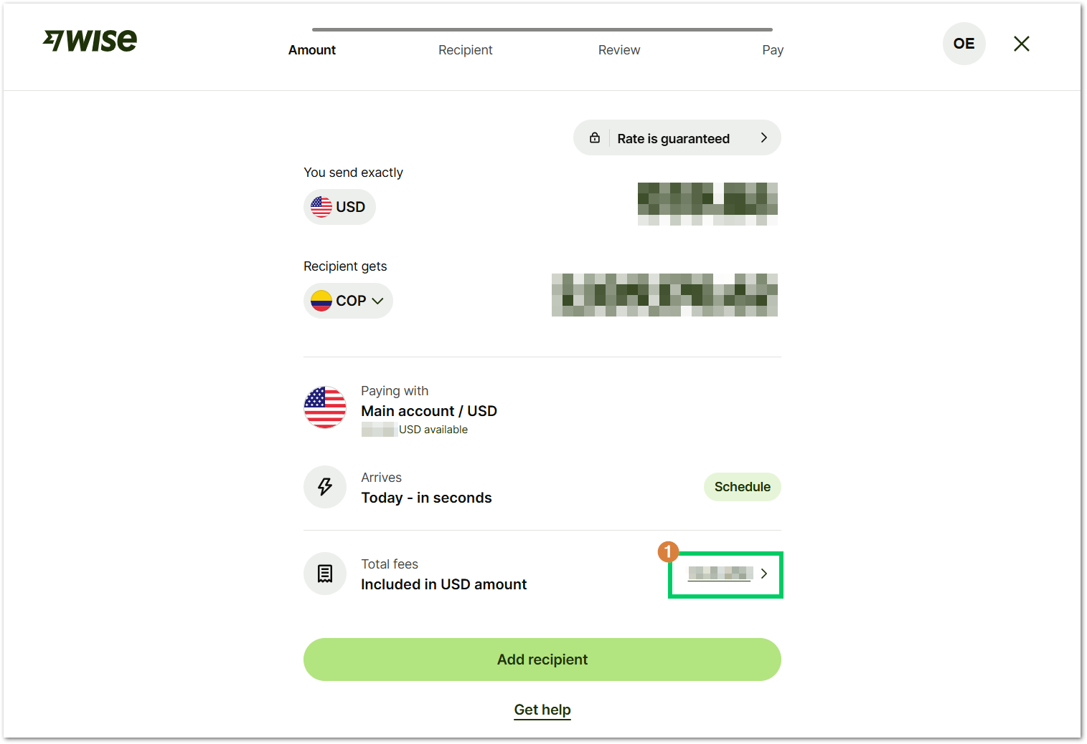
To set up recurring transfers, click the Schedule button.
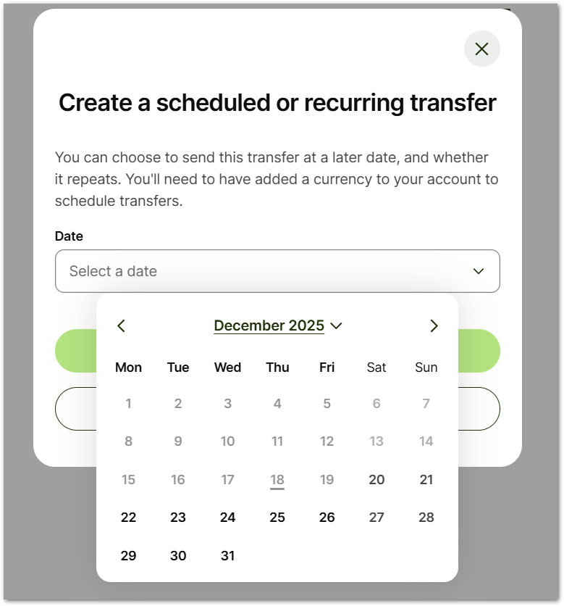
- Select Add recipient to select the account where you will send the money.
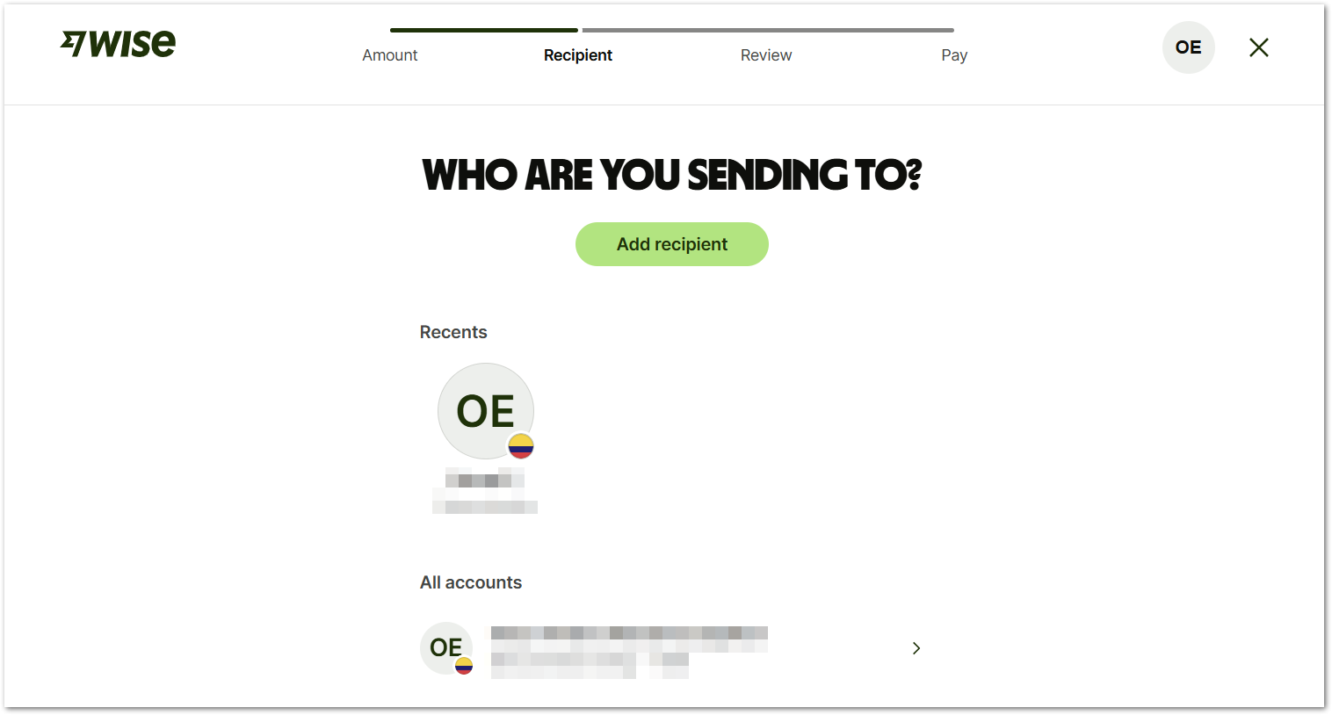
- Select Confirm and send to complete the transaction.
- You may see the payment as a pending task, in that case you need to review it.
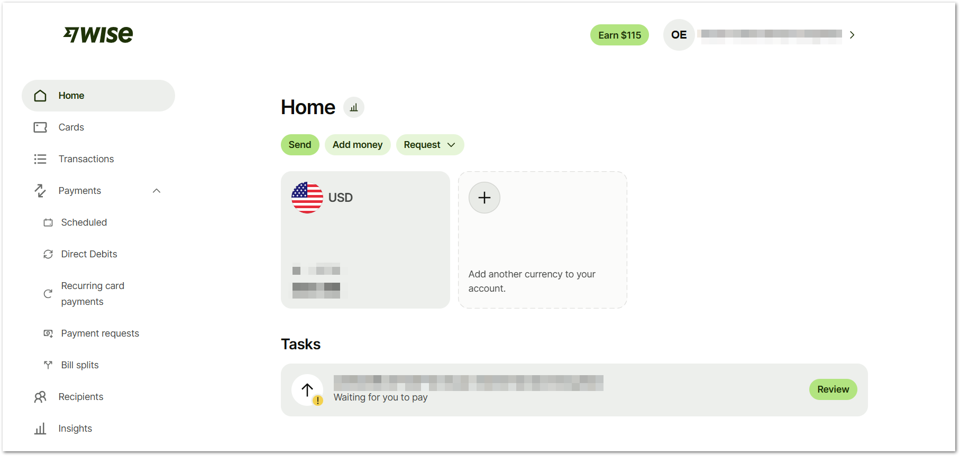
- In the transaction details, select the reason for sending the money and click Choose how to pay to complete the task.
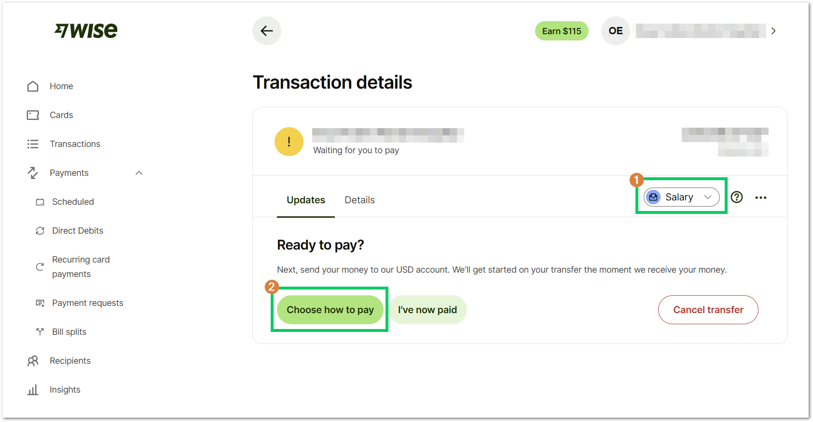
- Review the payment details and select Finish and pay. Once you click this option, the money will get in your local bank account.
Tip: For setting up, paying for, editing, and cancelling transfers visit the support website.

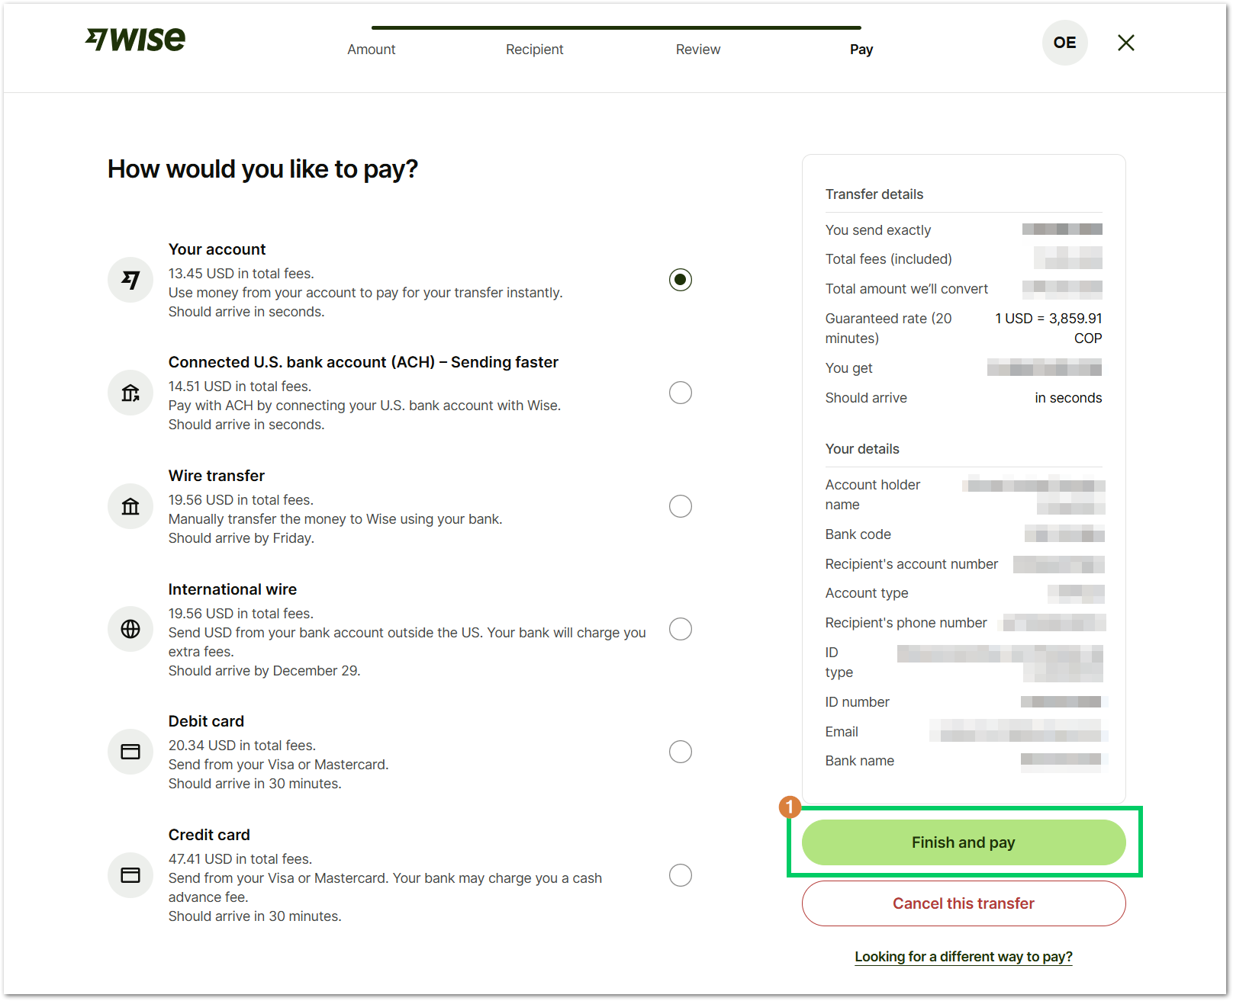
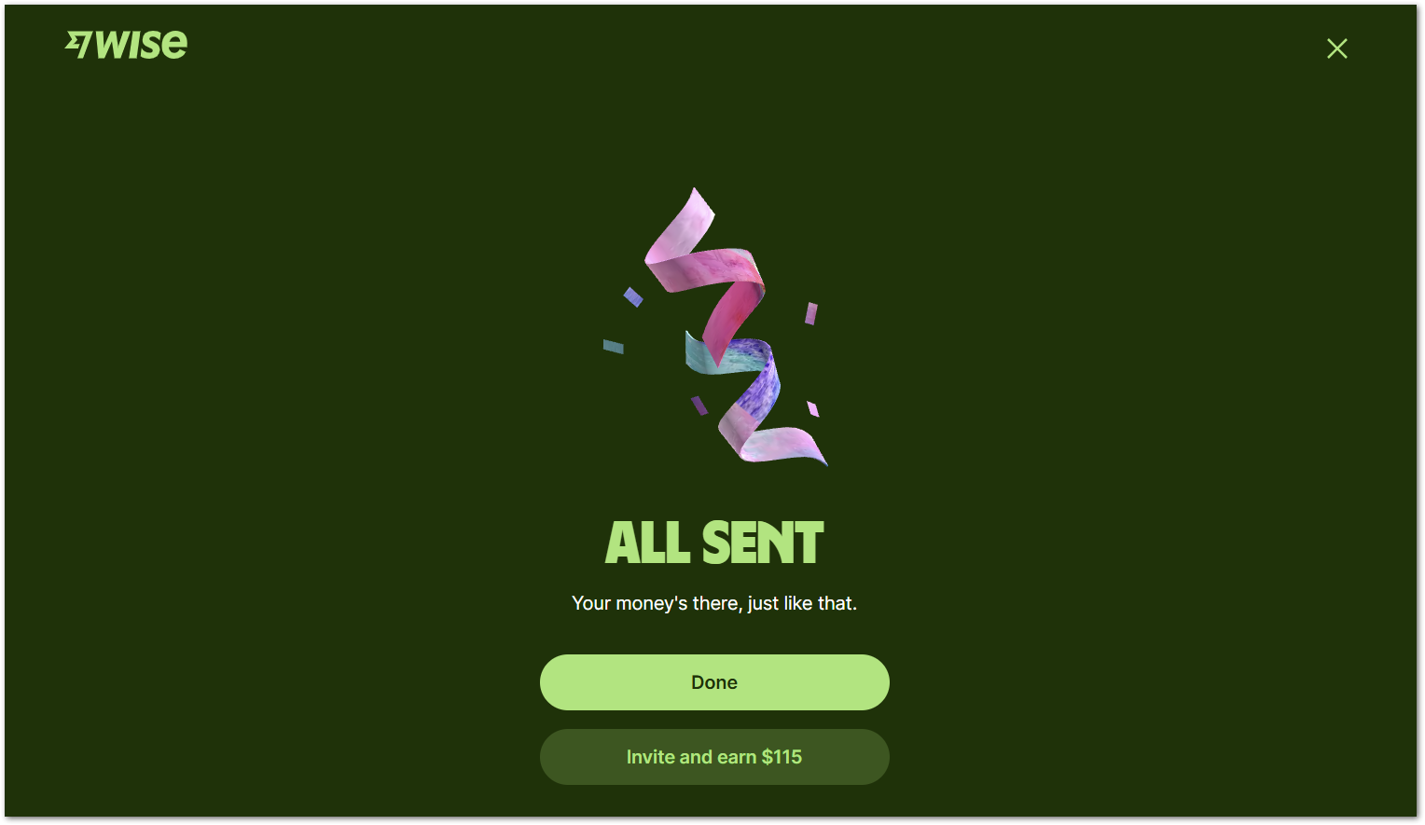

--- END OF THE DOCUMENT ---

